ASSIGNMENT- I

NAME: SOUMYADIP GHOSH

STREAM: CSE- A

ROLL NUMBER: 1951007

SUBJECT: OS LAB

Classwork

Program 2: Write a Shell Script that reads the user’s name and time from the system. Then, it should print a greeting on the terminal based on the time of the day along with the user’s name, current date & time, and also show the process ID of the terminal the user logged into.

Shell Script:

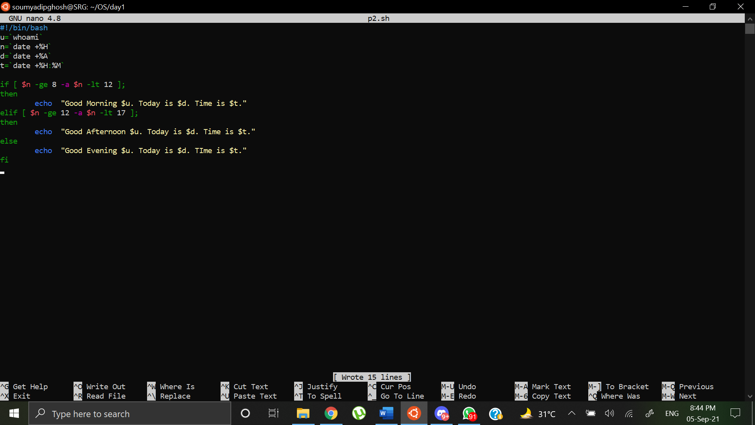

Output:

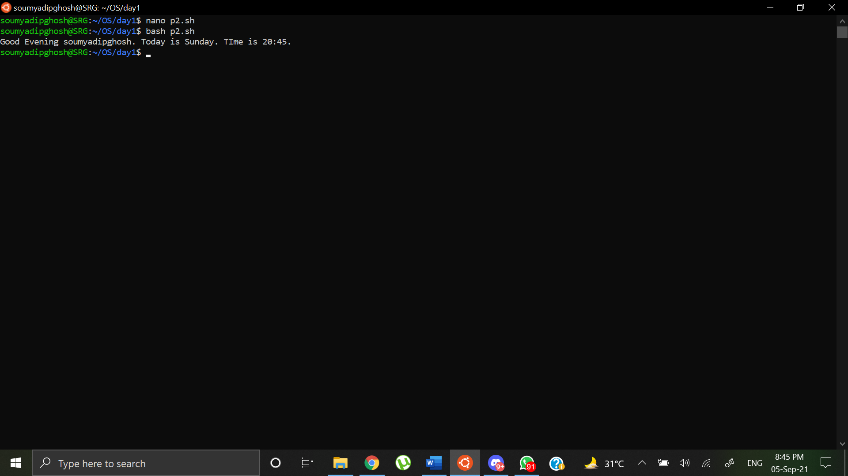

Program 3: Write a shell command that accepts a filename as argument and displays the last modification time, if the file exists and a suitable message if it does not.

Shell Script:

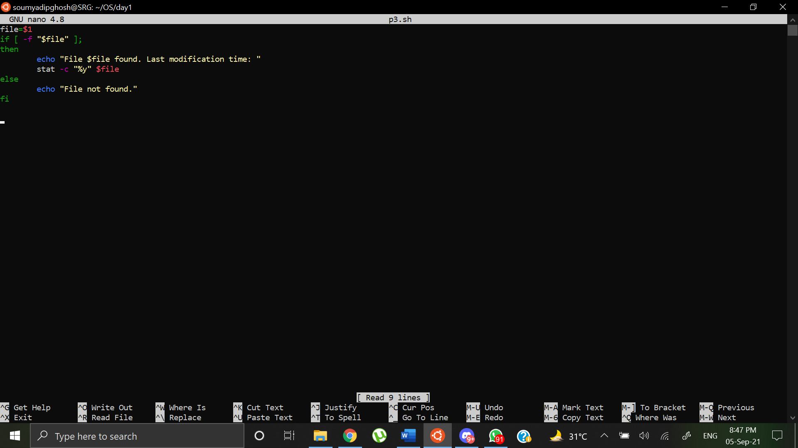

Output:

Inputs were given for a file that existed in the system and a file that didn’t exist in the system

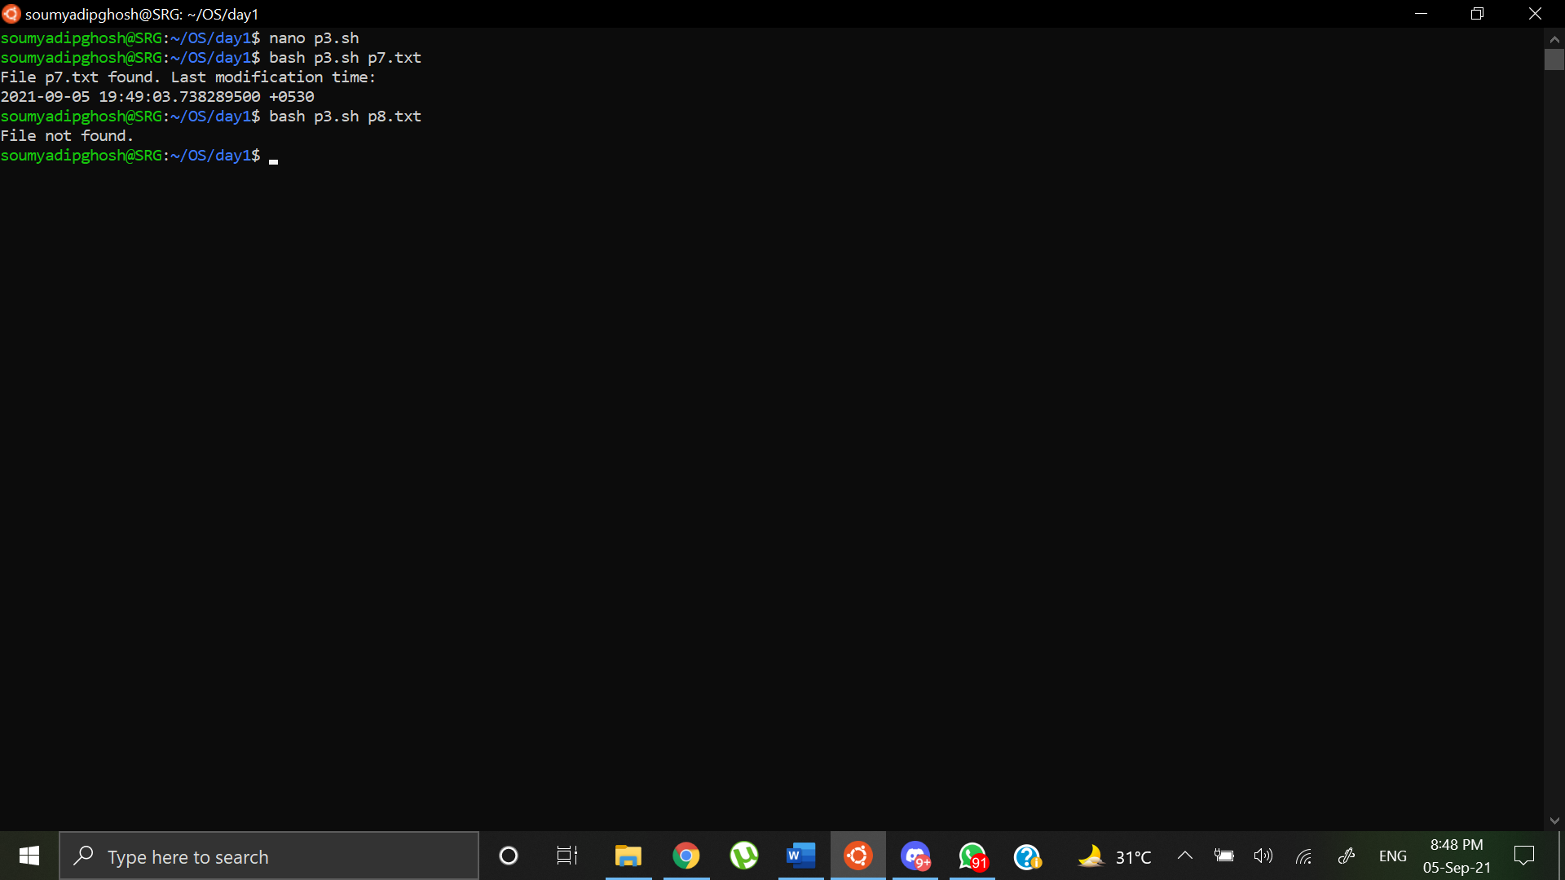

Program 4: Write a shell script that accepts two directories namely OS1 and OS2 as arguments and deletes those files in OS2 which are identical to their names in OS1.

Shell Script:

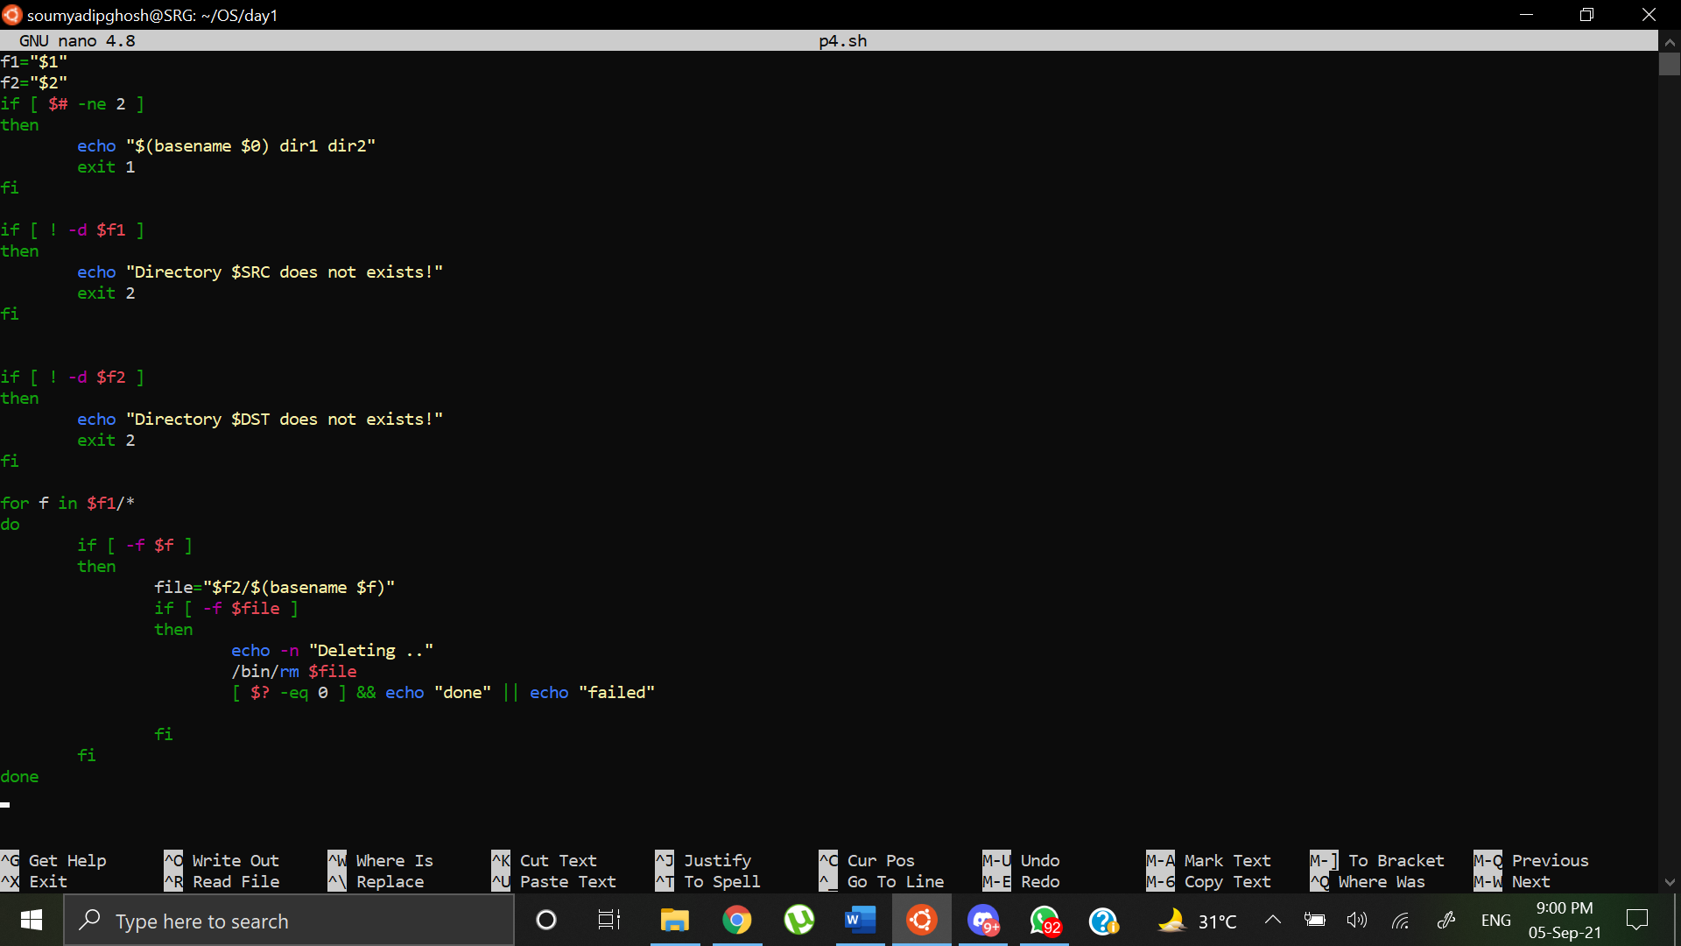

Output:

Files in OS1

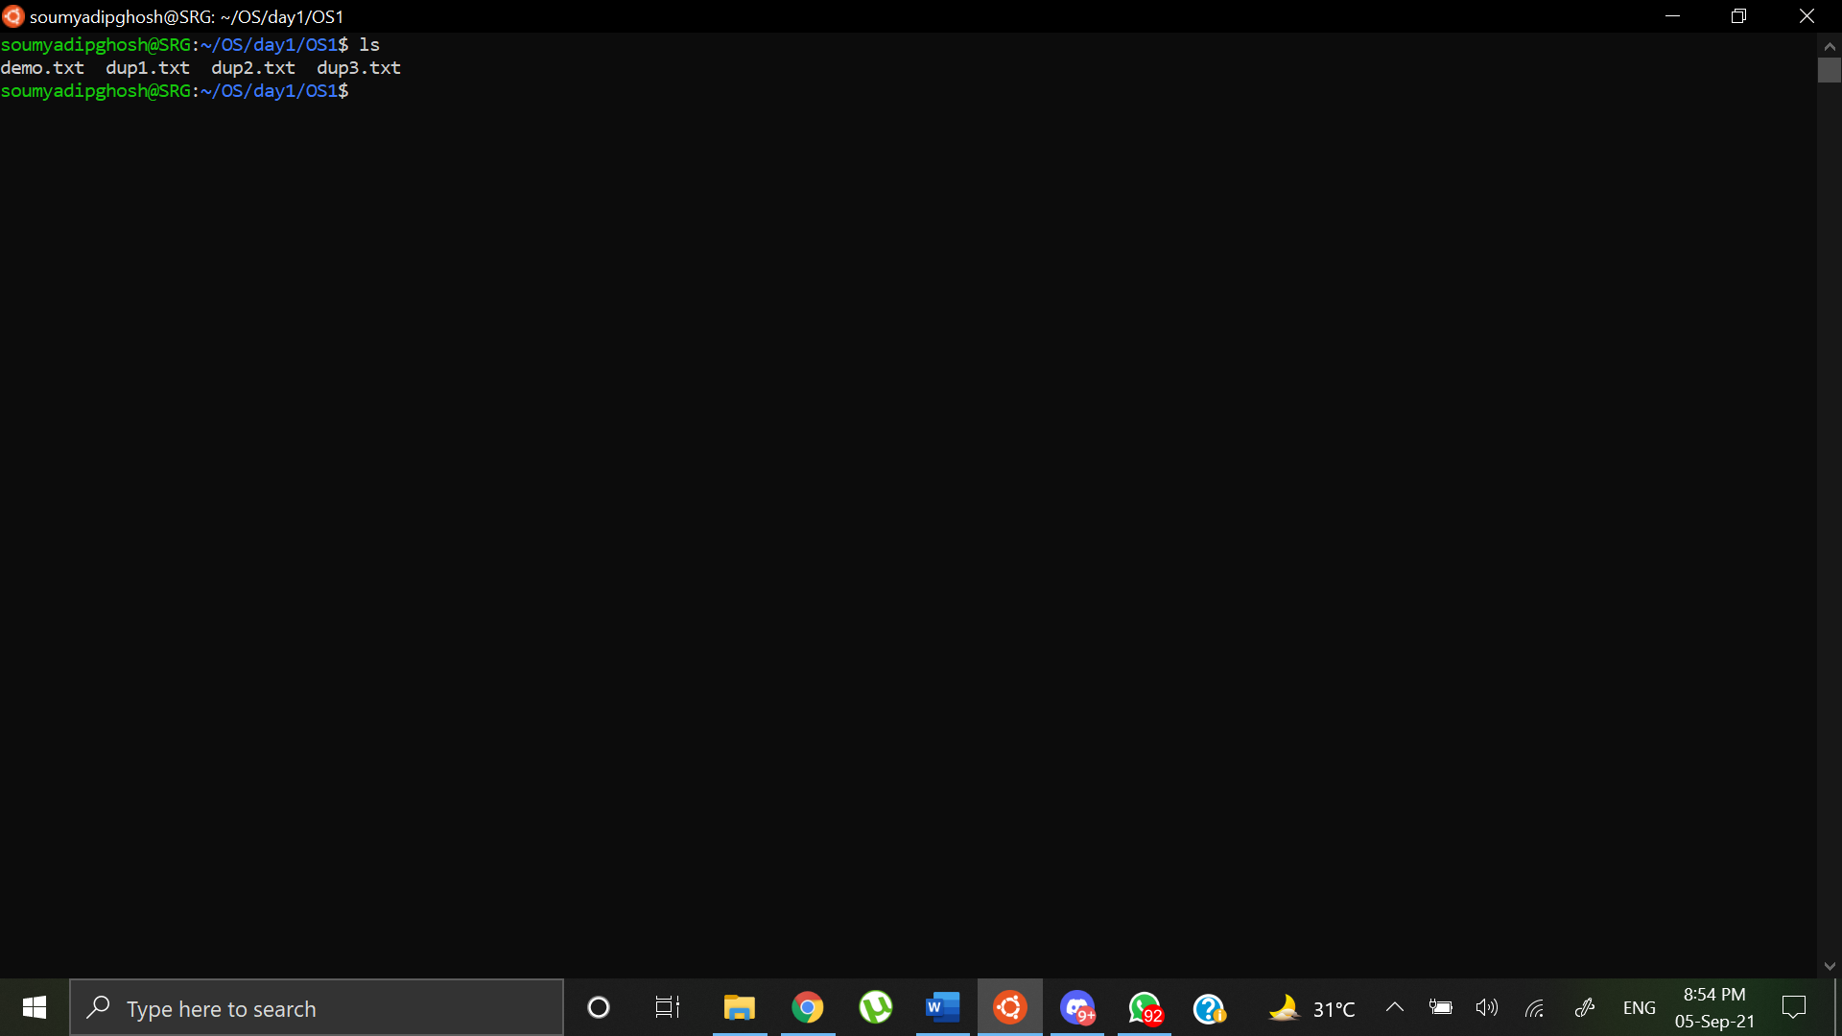

Files in OS2

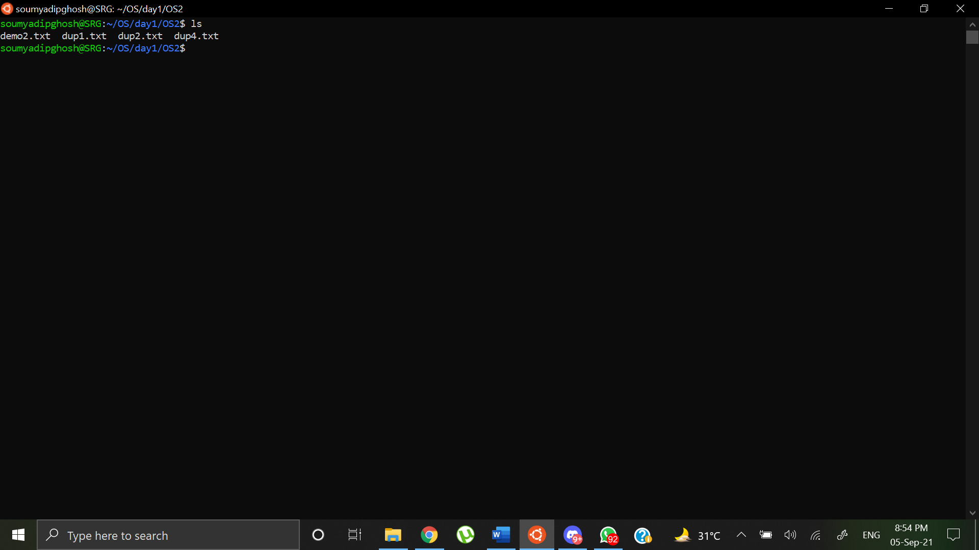

After running Shell Script:

Terminal Output:

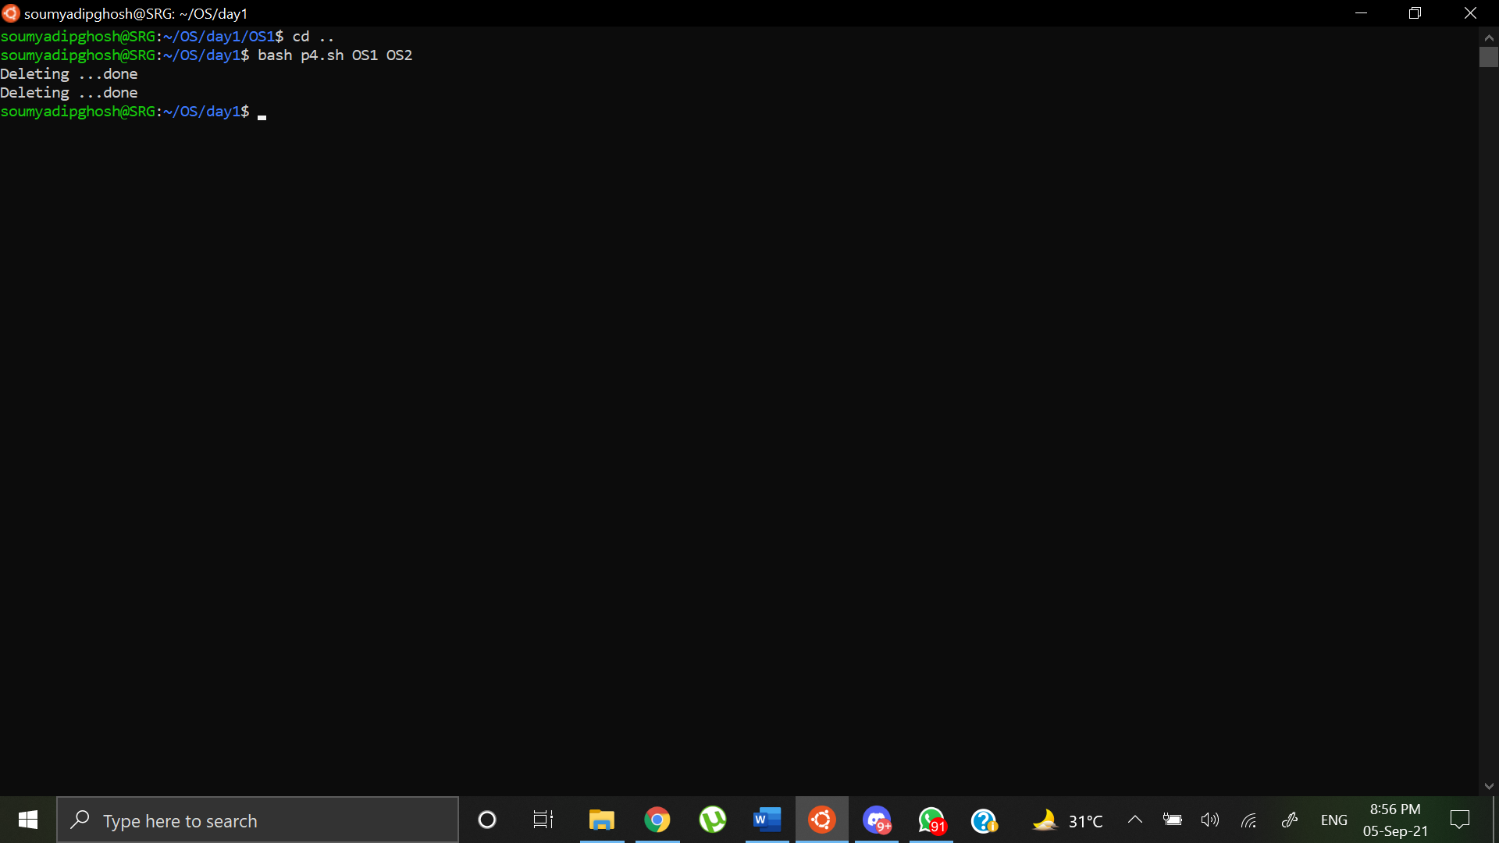

Files in OS1:

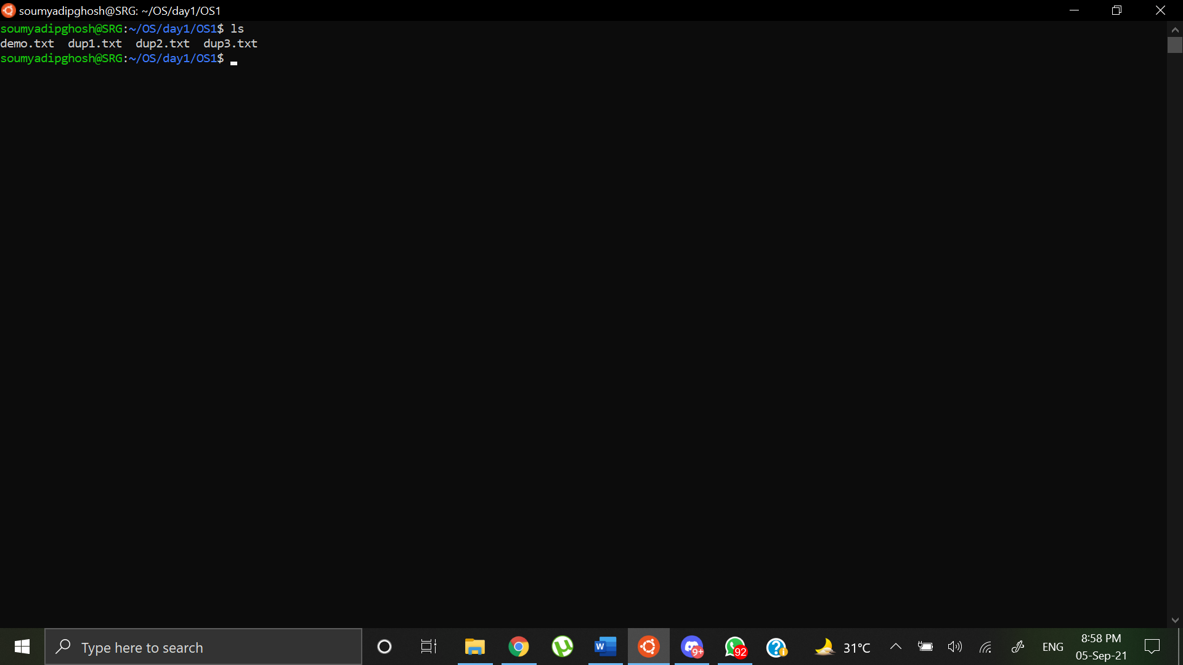

Files in OS2:

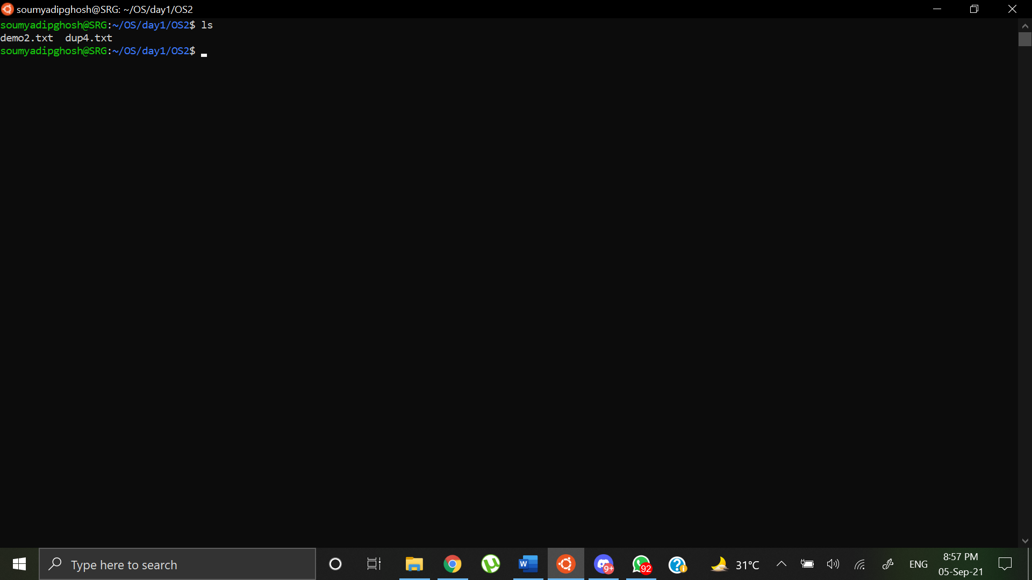

Homework

Program 2: Write a shell script to list the names of files under the current directory started with vowels.

Shell Script:

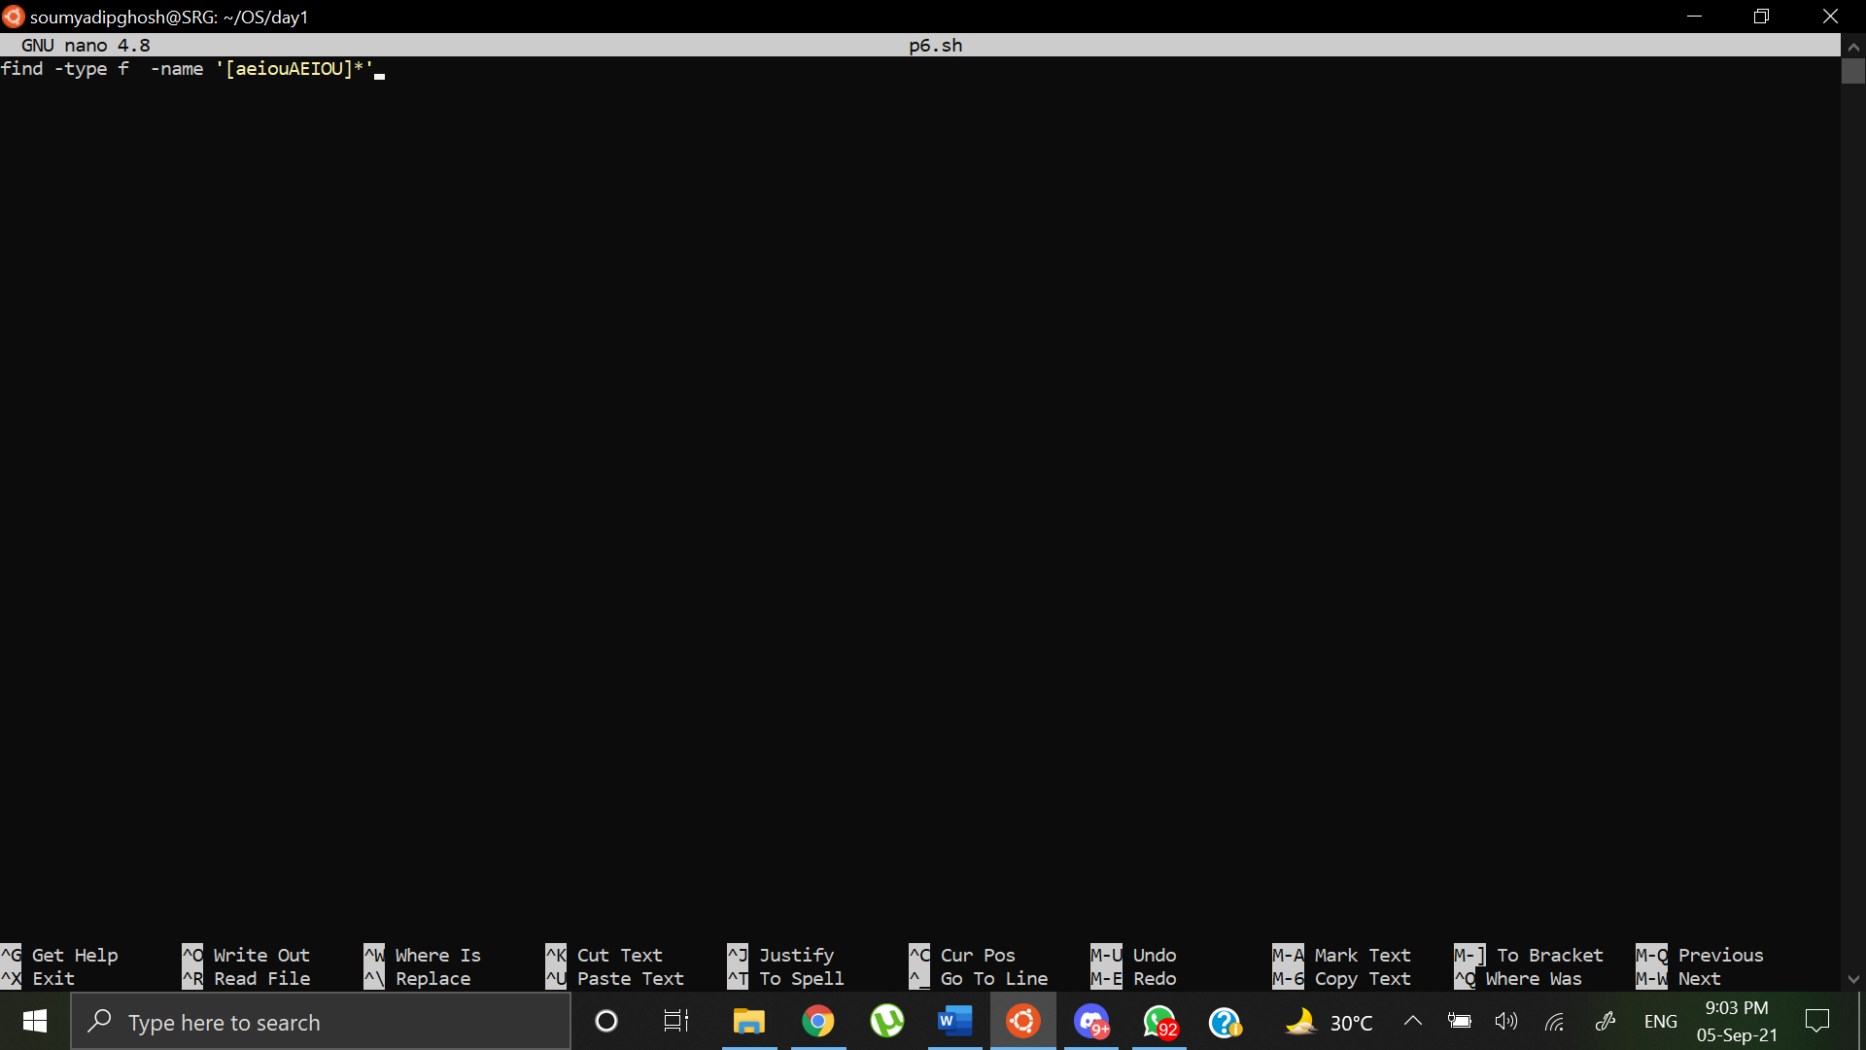

Output:

Files currently in directory

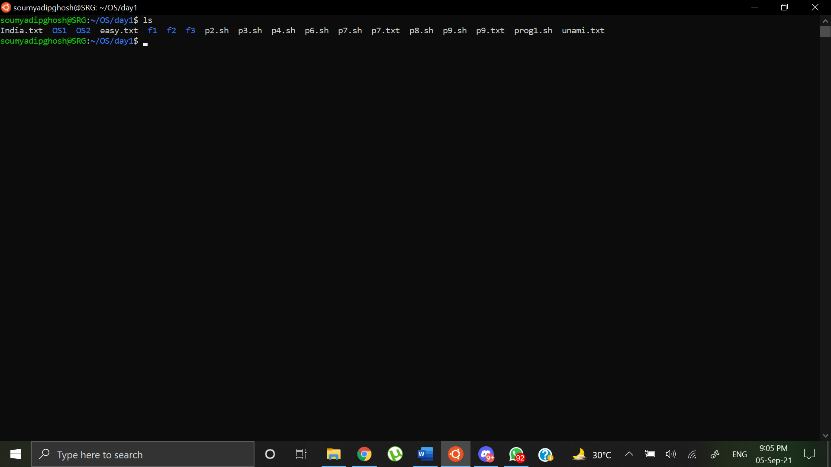

Output:

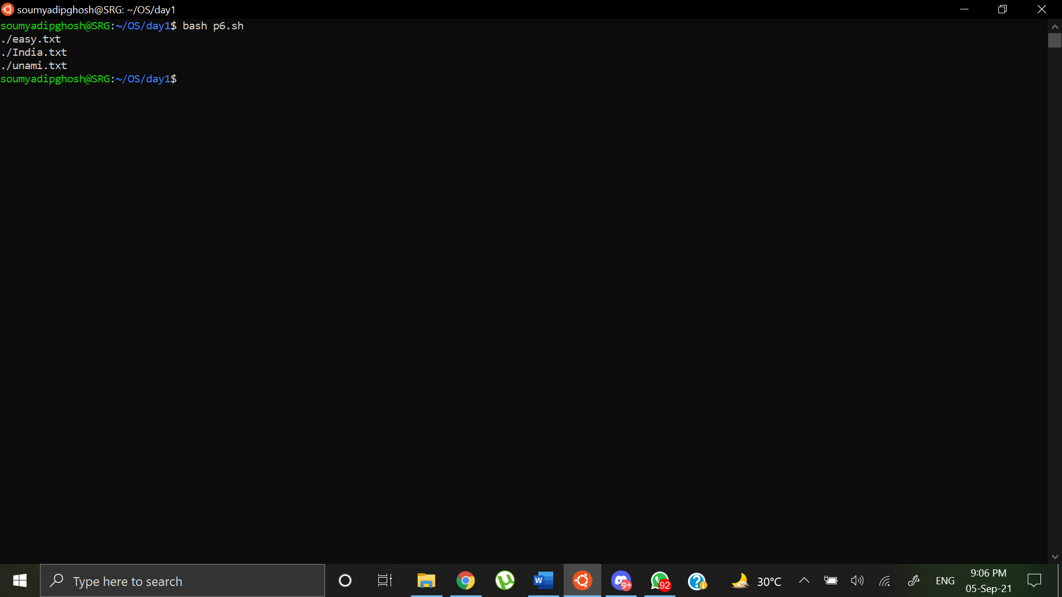

Program 3: Write a shell script to drop the lines which are matched with a given word.

Shell Script:

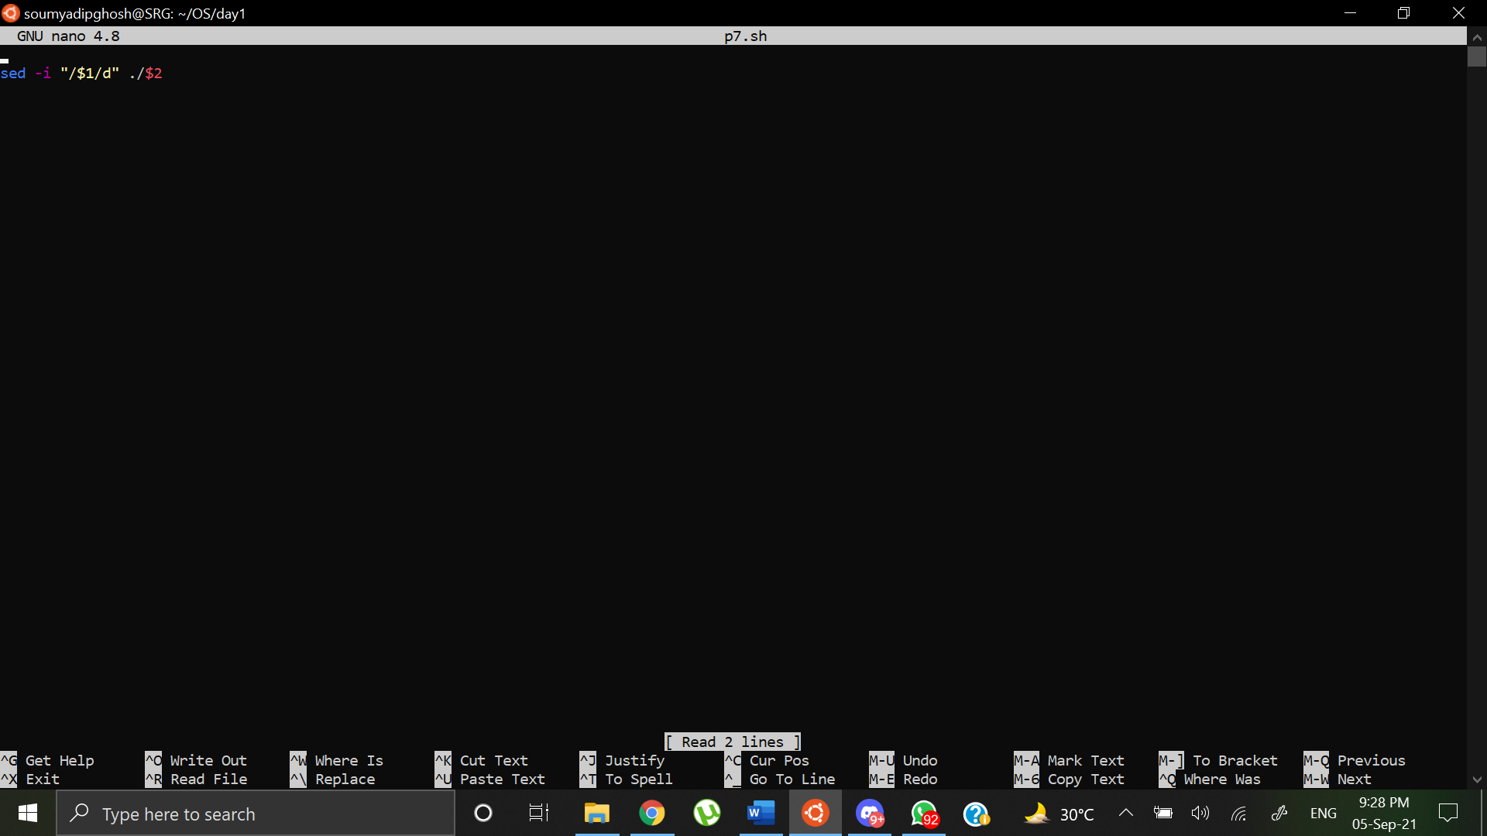

Output:

Contents of p7.txt

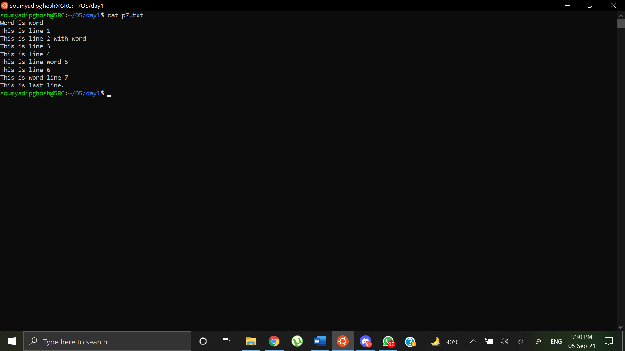

After running the script:

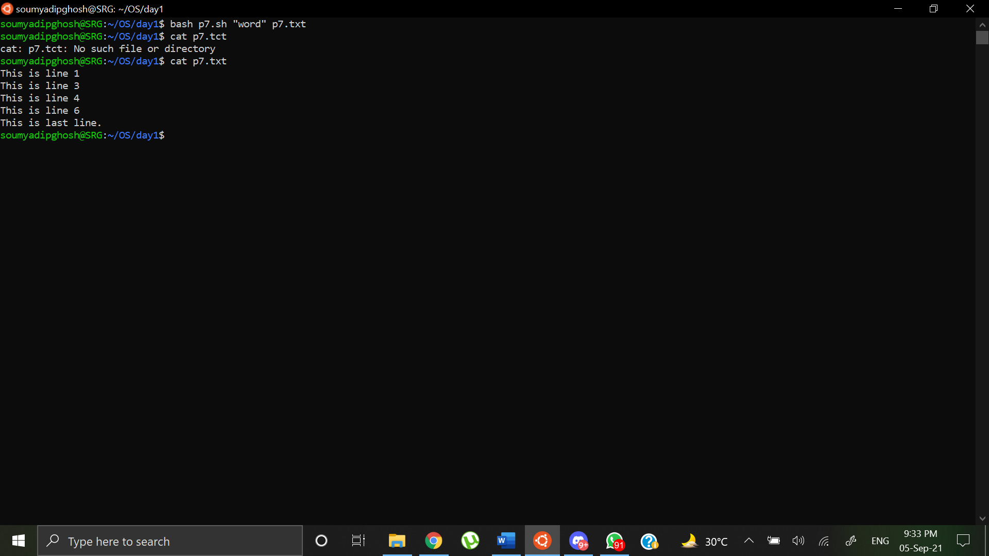

Program 4: Write a shell script that shows the names of all the non-directory files in the current directory and calculates the sum of the size of them.

Shell Script:

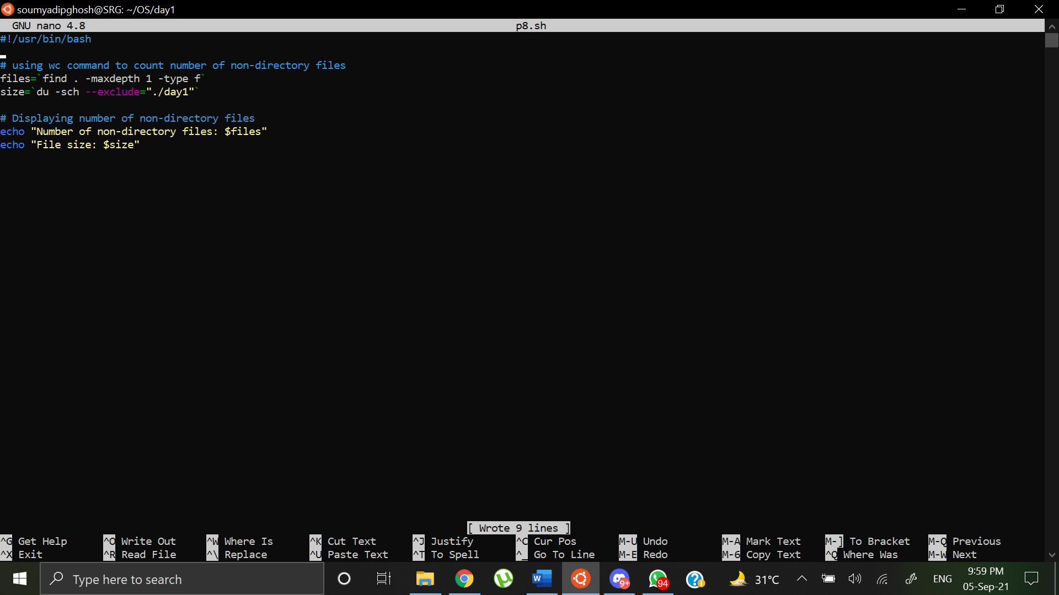

Output:

Contents of current directory:

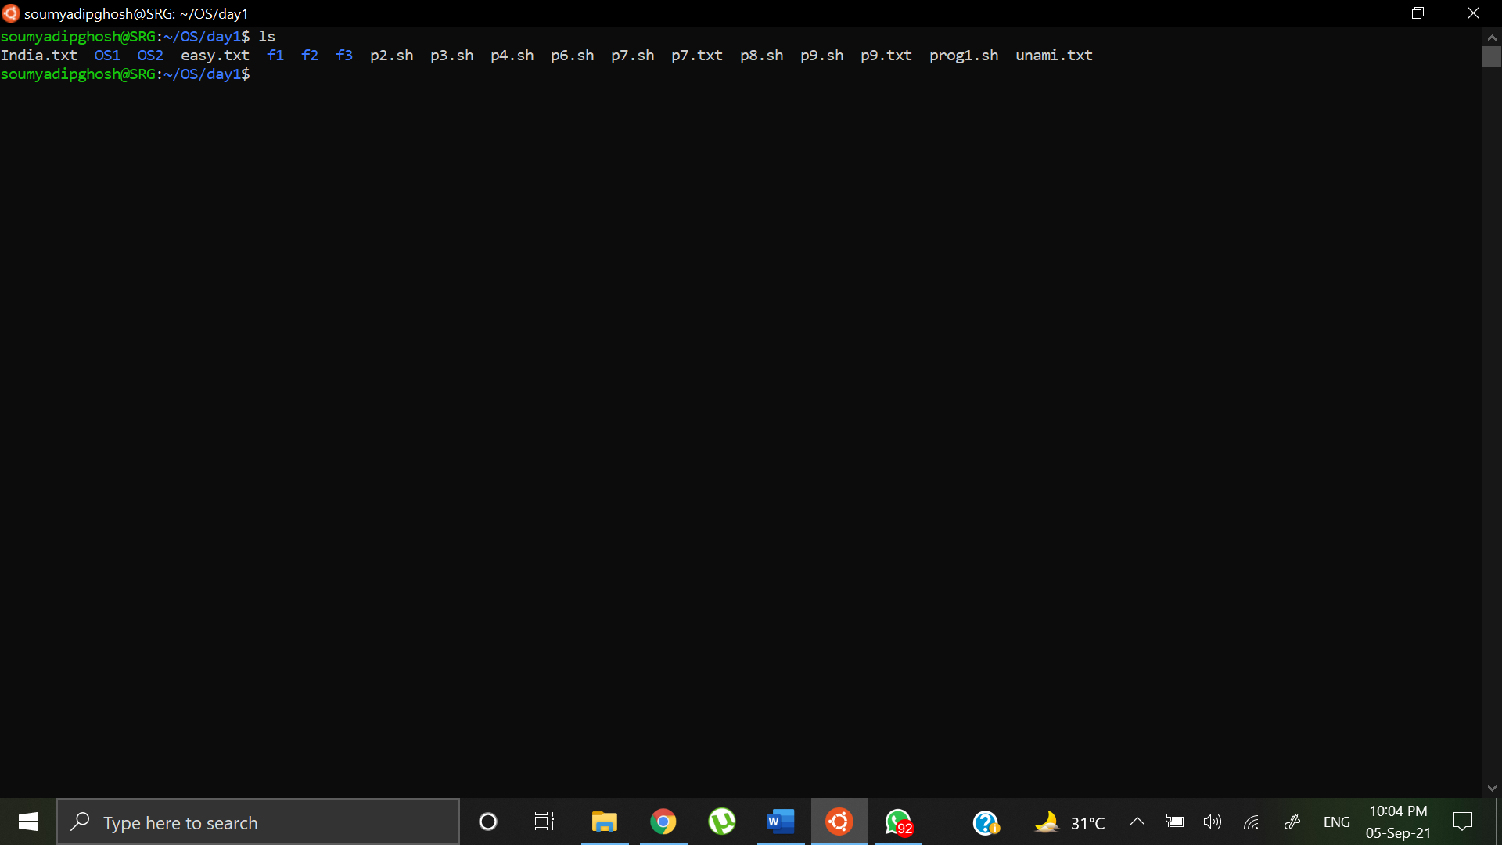

Terminal Output:

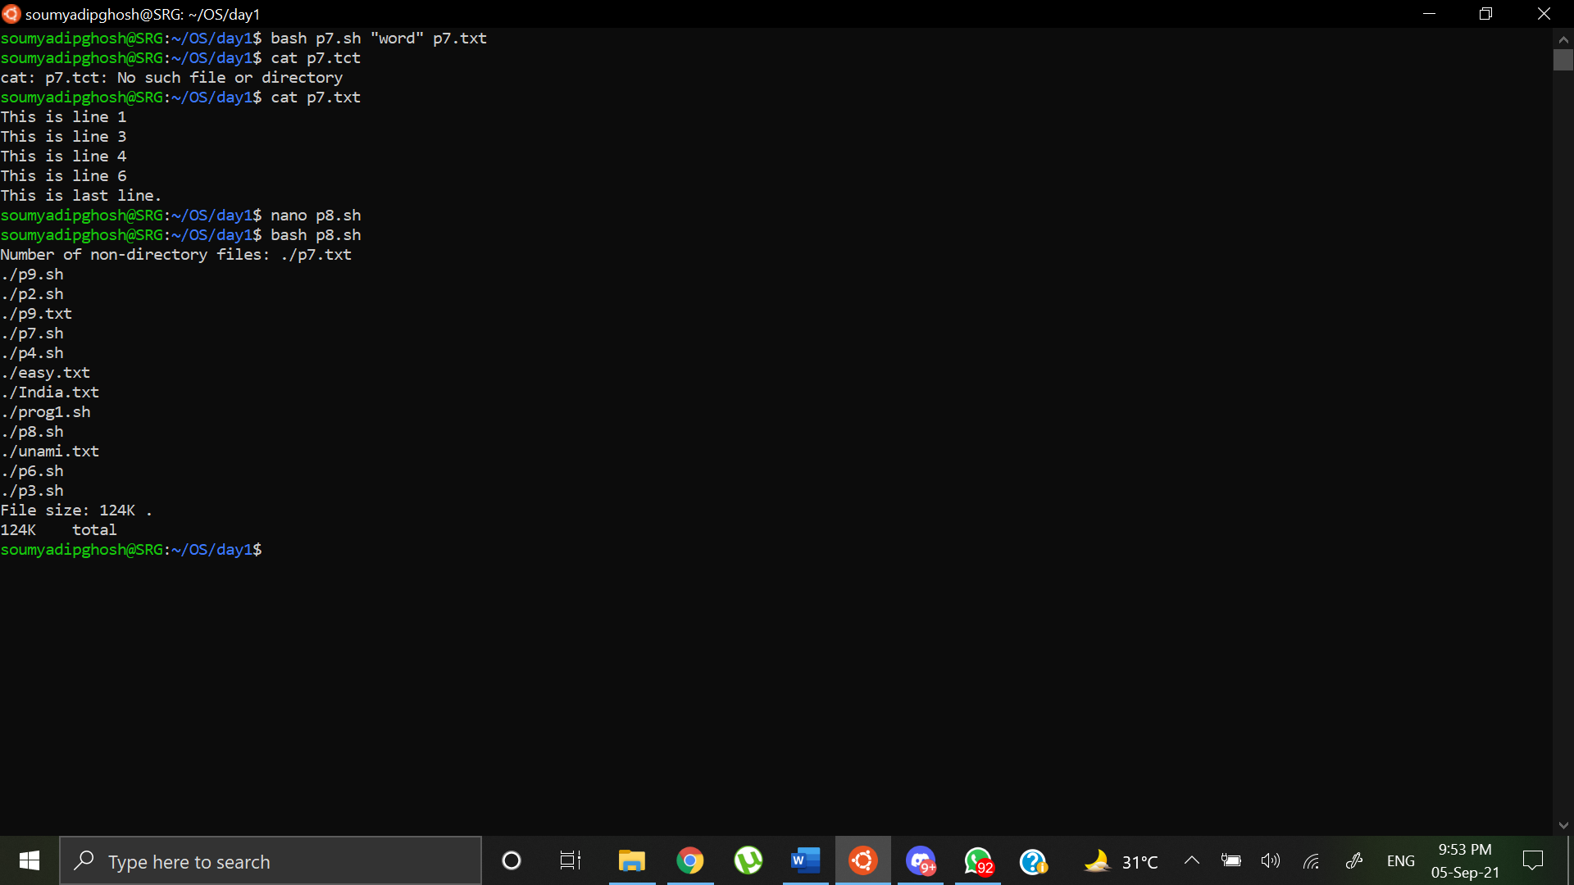

Program 5: Write a shell script to find the total number of words, characters, lines in the given file (name of the file given in command line argument).

Shell Script:

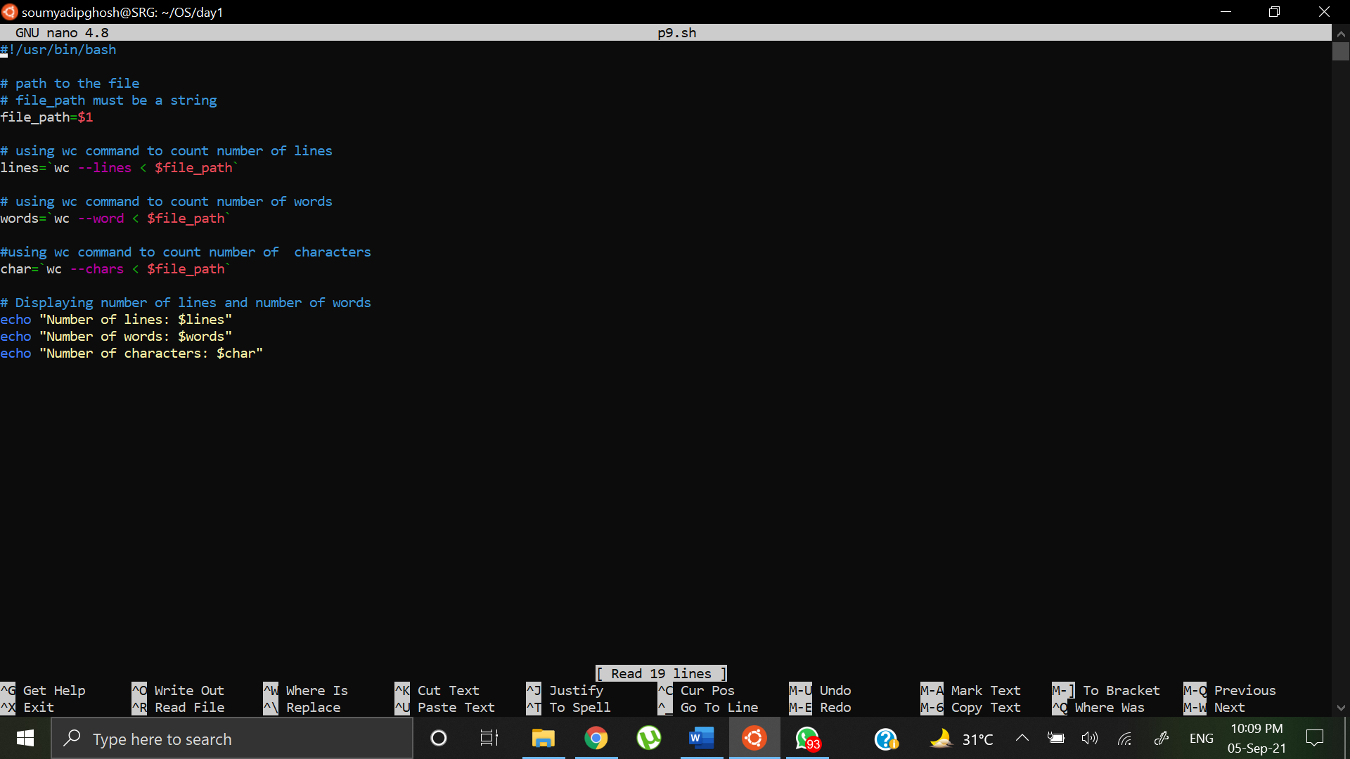

Output:

Contents of p9.txt

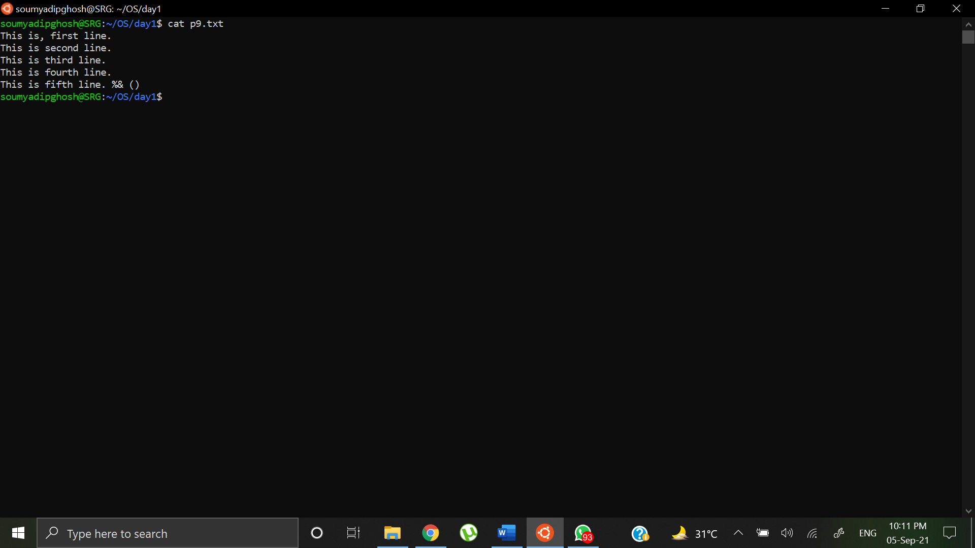

Terminal Output:

